For our ETL project we scraped NBA and WNBA statistics from <https://www.basketball-reference.com/> for the year 2019.

NBA: <https://www.basketball-reference.com/leagues/NBA_2019_per_game.html>

WNBA: <https://www.basketball-reference.com/wnba/years/2019_per_game.html>

Paul, Will, and I scraped NBA and WNBA statistics for 2019 for the entire league using beautifulsoup.

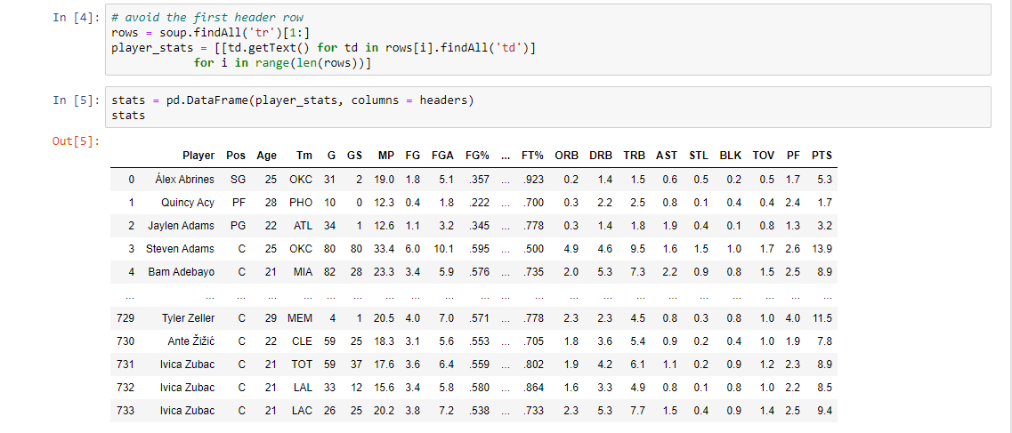

Our python code also included the creation of a dictionary of dataframes for easy viewing, however we were unable to export this dictionary to CSV.

We were also unsure how to export the dictionary straight to a database from jupyter, so we exported the full dataframe you see in the screenshot above to MongoDB.

